INTERNSHIP PROJECT REPORT
Personal Portfolio Website
A Full-Stack Web Application
Submitted by | Ekansh Tanwar
Internship Role | Full-Stack Web Development Intern
Organization | Skillbit Technologies
Duration | 05/06/26 – 04/08/26
Date of Submission | [DD Month YYYY]
GitHub Repository | GitHub

1. Introduction
This report documents the design, development, and implementation of the Personal Portfolio Website, built as the first project for the Full-Stack Web Development internship. The goal of the project was to design and deploy a personal website that presents the intern's skills, project work, and contact information, backed by a real server-side application rather than static pages alone.
The project was used as an opportunity to gain hands-on experience across the full web development stack: structuring a front end with HTML, CSS, and JavaScript, and building a back end with Node.js and the Express framework to serve data and handle form submissions.

2. Objective
The specific objectives of this project were to:
- Design and build a responsive personal portfolio website using HTML, CSS, and JavaScript.
- Implement a Node.js/Express back end that manages and serves the site's data (projects) rather than hardcoding it into the page.
- Build a working contact form that sends data from the browser to the server and persists it.
- Apply full-stack concepts: client–server communication, REST-style API design, and separation of front end and back end concerns.
- Deploy the finished project to GitHub (source control) and prepare it for hosting.

3. Technology Stack
Layer | Technology
Front end structure | HTML5 (semantic markup)
Front end styling | CSS3 — Flexbox, CSS Grid, custom properties, responsive breakpoints
Front end behavior | Vanilla JavaScript (Fetch API, DOM manipulation, form handling)
Back end runtime | Node.js
Back end framework | Express.js
Data storage | JSON files (projects.json, messages.json)
Version control | Git & GitHub

4. System Architecture
The application follows a simple client–server architecture:
- The Express server (server.js) serves static front-end files (HTML, CSS, JS) from the public/ folder.
- A REST-style API, mounted at /api, exposes two endpoints: GET /api/projects (returns project data) and POST /api/contact (accepts and stores contact form submissions).
- The front end never hardcodes project content — it fetches it from the API at page load using JavaScript's fetch(), then renders project cards dynamically in the DOM.
- Data is persisted in JSON files on the server rather than a database, which keeps the project lightweight while still demonstrating real client–server data flow.

4.1 Folder Structure

portfolio-website/ server.js (Express app entry point) package.json routes/api.js (API route handlers) data/projects.json (project data) data/messages.json (stored contact form submissions) public/ index.html css/style.css js/main.js

5. Key Features
- Responsive hero, about, skills, projects, and contact sections in a single-page layout.
- Projects are loaded dynamically from the back end, so adding a new project only requires editing a JSON file — no HTML changes needed.
- Functional contact form: submissions are validated server-side and saved with a timestamp.
- Mobile-friendly navigation with a collapsible menu.
- Accessible markup: semantic HTML, visible keyboard focus states, and reduced-motion support.

6. Implementation Details

6.1 Front End
The front end is built with plain HTML, CSS, and JavaScript (no framework), which kept the codebase easy to understand while learning full-stack fundamentals. CSS uses custom properties (variables) for a consistent color and type system, and Flexbox/Grid for layout across all screen sizes.

6.2 Back End
The back end uses Express to serve the static front end and to expose two API routes. The GET /api/projects route reads and returns data/projects.json. The POST /api/contact route validates the incoming name, email, and message fields, appends a timestamped entry to data/messages.json, and returns a success or error response as JSON.

6.3 Front End – Back End Communication
The browser communicates with the server using the Fetch API. On page load, main.js requests project data from /api/projects and renders it into the DOM. When the contact form is submitted, JavaScript intercepts the default form submission, sends the form data as JSON to /api/contact, and displays a success or error message based on the server's response — all without a page reload.

7. Screenshots
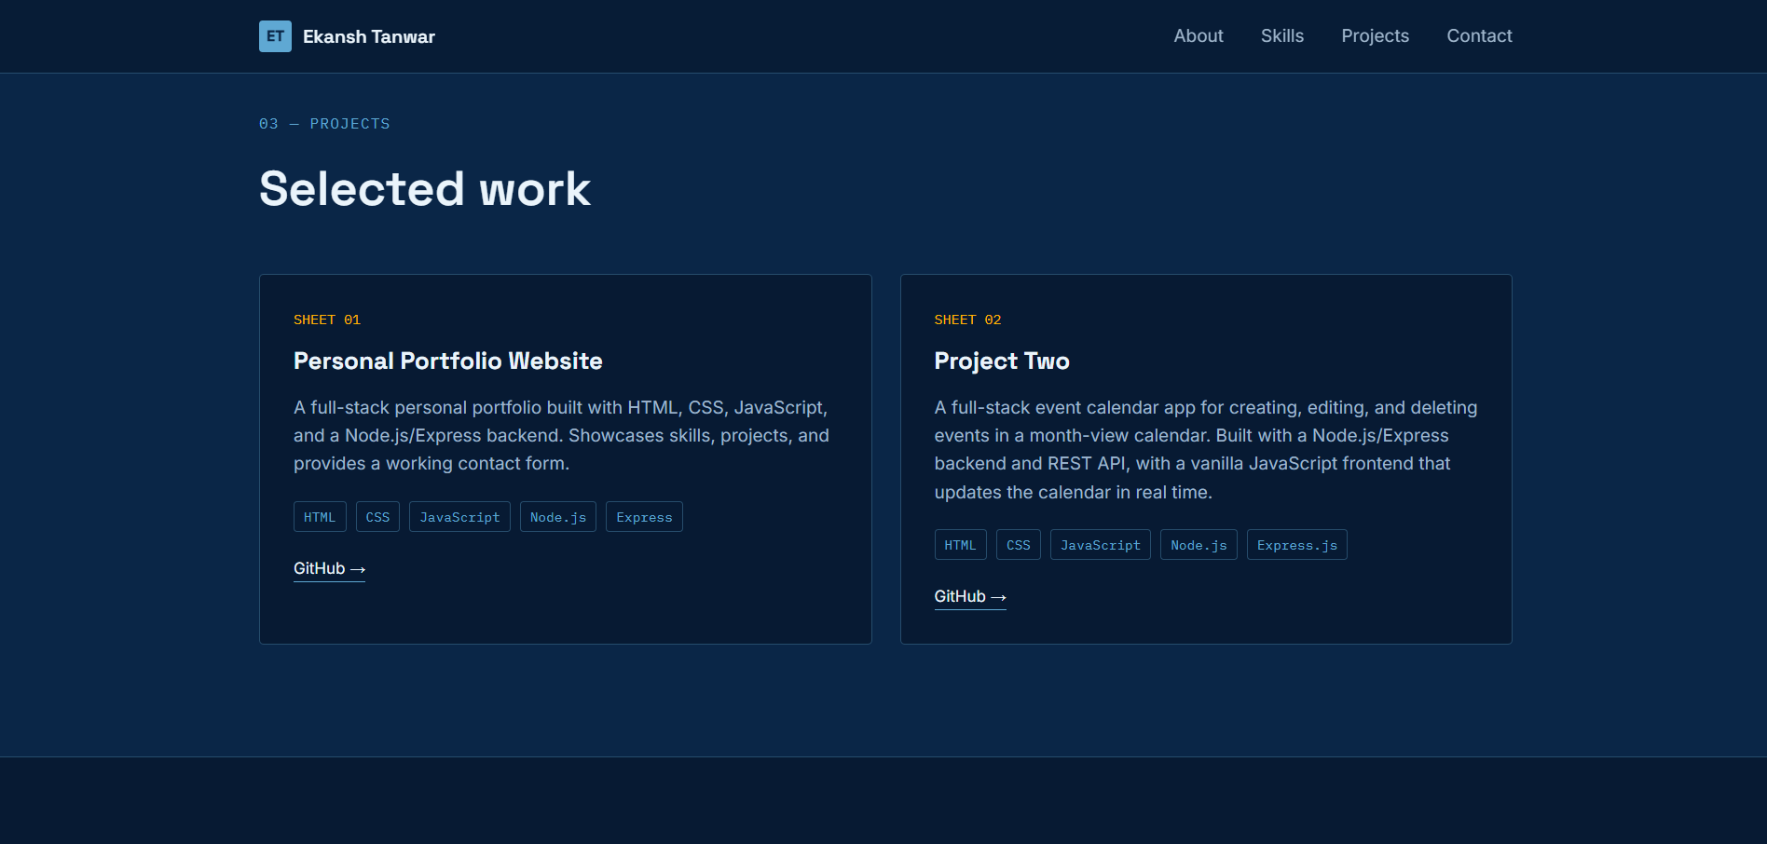
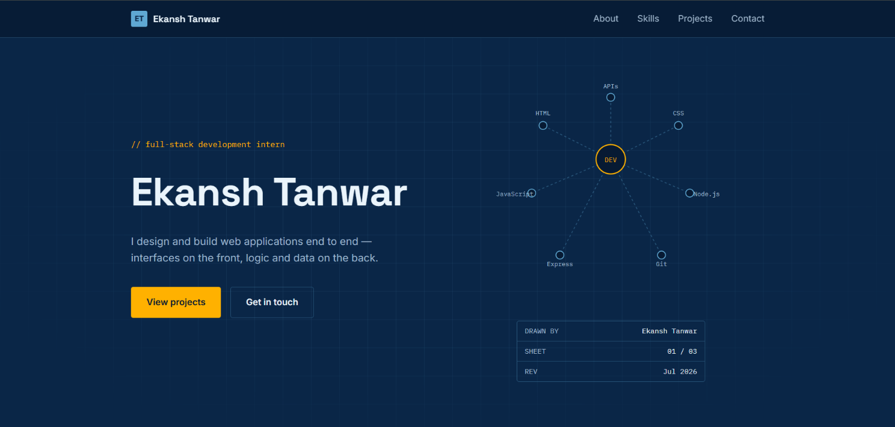

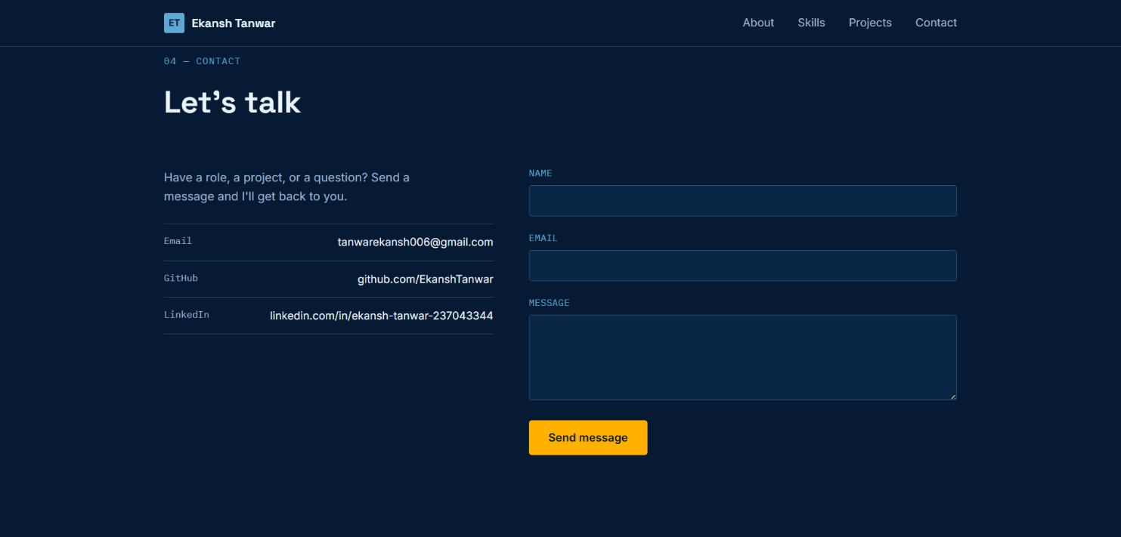
8. Challenges Faced & Solutions
- Challenge 1
Problem : Running npm run alone just listed the available scripts instead of starting the server.
Solution : Learned that npm start is a special shortcut npm recognizes directly, while custom scripts need npm run <script-name>.

- Challenge 2
Problem : By default, submitting an HTML form reloads the page, which would have interrupted the flow of showing a success message from the backend.
Solution : Used event.preventDefault() in main.js to stop the default form behavior, then sent the data to /api/contact using the fetch() API instead.

- Challenge 3
Problem : Since the frontend fetches project data from /api/projects rather than having it hardcoded in the HTML, opening index.html directly in a browser (without the Express server running) showed no projects at all.
Solution : Understood that the site needs npm start running first, since the frontend depends on the backend to serve the project data.

9. Key Learnings
- How a front end and back end communicate over HTTP using a REST-style API.
- How to structure an Express application with separate route files.
- How to read from and write to JSON files on the server as a lightweight data store.
- How to use the Fetch API to load data into a page dynamically instead of hardcoding it.
- Version control basics with Git and GitHub for managing project history.

10. Conclusion
The Personal Portfolio Website project met its objective of producing a working full-stack web application: a responsive front end that presents the intern's skills and work, backed by a Node.js/Express server that manages project data and handles contact form submissions. The project provided practical, end-to-end experience with the core building blocks of full-stack development.

11. References & Links
- GitHub Repository: GitHub
- Google Drive Submission: Drive
- Node.js Documentation: Nodejs
- Express Documentation: Expressjs

